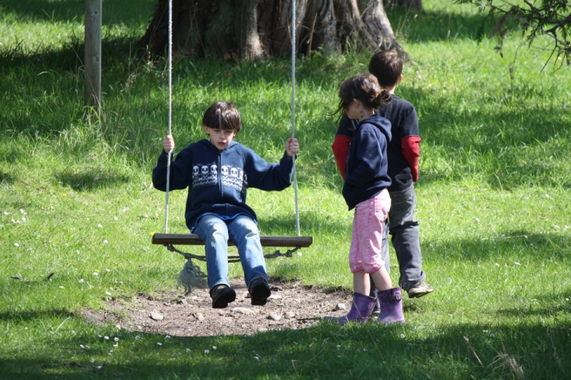
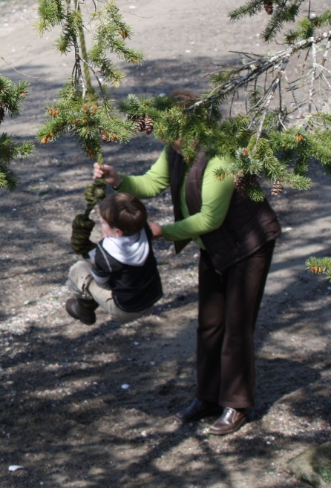
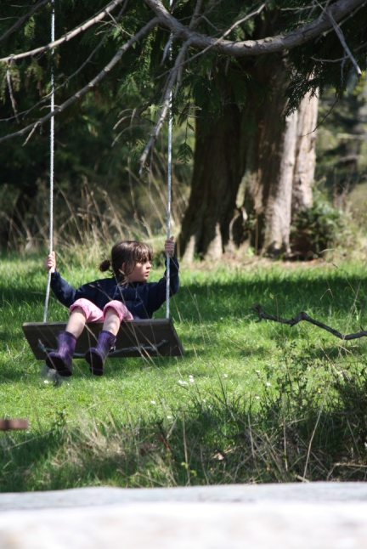
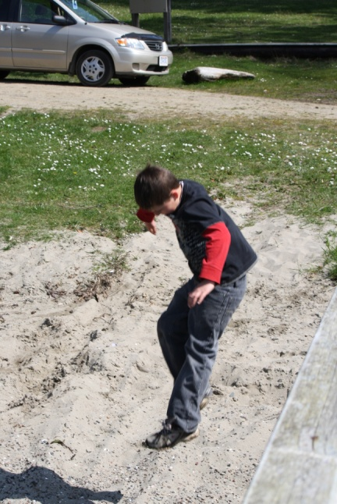
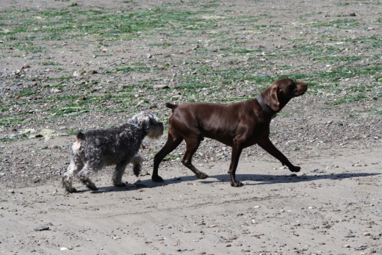
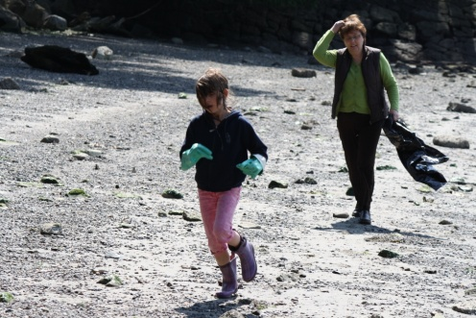
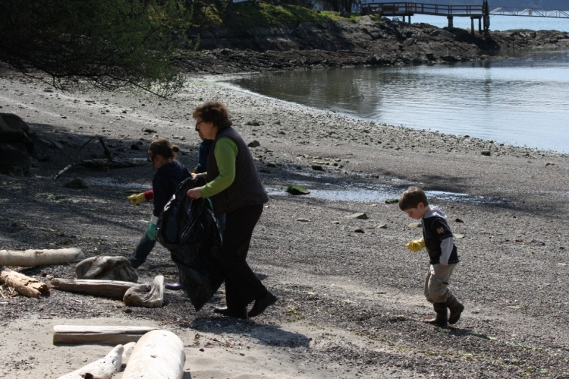
A Trip to the Beach

Upcoming Events...

Friday April 29th – Aboriginal Education Day on Galiano Island.

“Don’t see any here”
“Nope, not here”
“Where’s the garbage”
April 26-29: Tuesday to Friday
May 2-5: Monday to Thursday

